

MINI PROJECT (2021-22)

ON

Covid Detection Using X-ray Images

**NAME:**  SRISTI GANGWAR

**ROLL NO:** 2014897

**SEMESTER:** 6

**SUBMITTED TO: Mr. Pankaj Kumar**

**Ms. Parul Madan**

Abstract

COVID-19 has become a global disaster that has disturbed the socioeconomic fabric of the world. Efficient and cost-effective diagnosis methods are very much required for better treatment and eliminating false cases for COVID-19. COVID-19 disease is a type of respiratory syndrome, thus lung X-ray analysis has got the attention for an effective diagnosis. Hence, the proposed study introduces an Image processing based COVID-19 detection model Covid Detector, which is trained on a dataset of chest X-ray images belonging to three categories: COVID-19, Pneumonia, and Normal person.

INTRODUCTION

Coronavirus pandemic commonly known as COVID-19 has challenged and changed the socioeconomic world order. After witnessing great advancements in technology, nobody had expected that human beings would experience such a loss of health and wealth. Due to no specific treatment available, authorities are only relying on behavioral treatments to face such pandemics. Most of the countries have experienced a complete shutdown to break the chain of virus spread. World Health Organization (WHO) has released guidelines on personal and social hygiene, and to exercise social distancing. COVID-19 is a type of respiratory syndrome which is quite similar to Pneumonia. Basic symptoms are dry cough, fatigue, shortness of breath, and mild fever. These properties make the identification of these diseases even more difficult. Radiographic images such as X-rays and CT scans of lungs are capable of providing enough information .

In this project we have developed an artificial neural network for the covid detection.

A typical artificial neural network will have three types of layers:

Input, hidden and Output.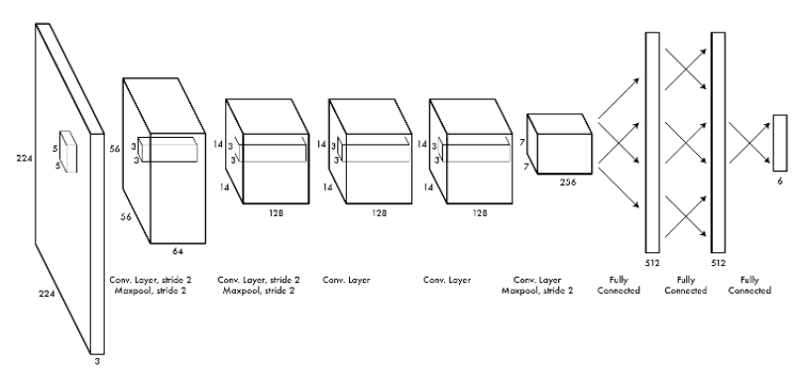

A Convolutional Neural Network or CNN is a type of artificial neural network, which is widely used for image/object recognition and classification. Deep Learning thus recognizes objects in an image by using a CNN.

ABOUT DATA

This dataset consists of 1823 images of an annotated posteroanterior (PA) view of Chest X-ray images. Labeled Optical Coherence Tomography(OCT) and CXR Images used for viral pneumonia and non-pneumonia or normal cases. The dataset consists of 536 images of COVID-19,619 images of viral pneumonia, and 668 images of normal cases. The age range of COVID-19 cases in the dataset is 18-75 years.

REQUIREMENTS

**LANGUAGE USED:** Python

**HARDWARE REQUIREMENTS:** Windows Desktop

**REQUIRED INSTALLMENTS:**

Libraries:

* Tensorflow
* Streamlit
* Opencv
* Pillow

MOTIVATION

Now-a-days living with COVID has become a new norm, but we have to have methods which can instantly tell the possibility of covid so these models are a lot more helpful.

METHODOLOGY

I used tensorflow,streamlit and PIL for my project.

There are two main steps:

1.Training the Model.

2.Deploy the model using streamlit

Training the Model :

1.Importing all required libraries and importing dataset and displaying.

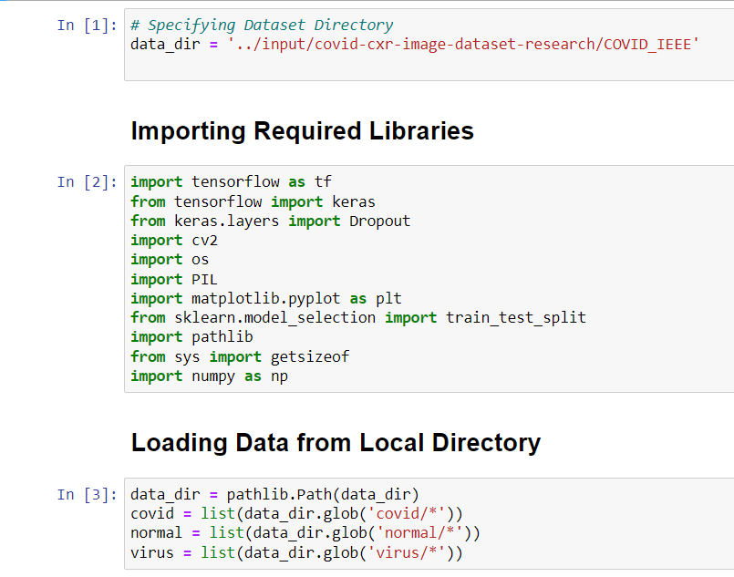

2.Analyzing the data

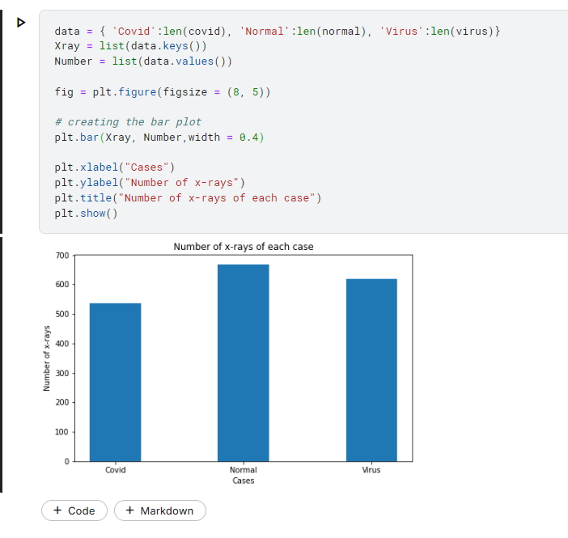

3.Augumentation of data

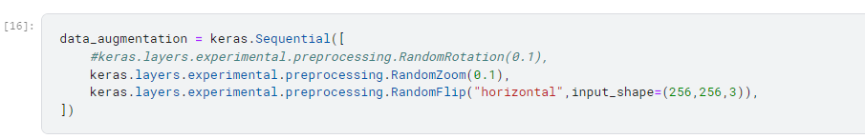

4.Normalization of data

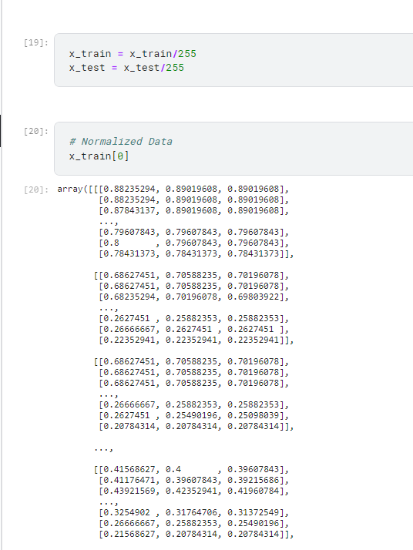

5.Model building

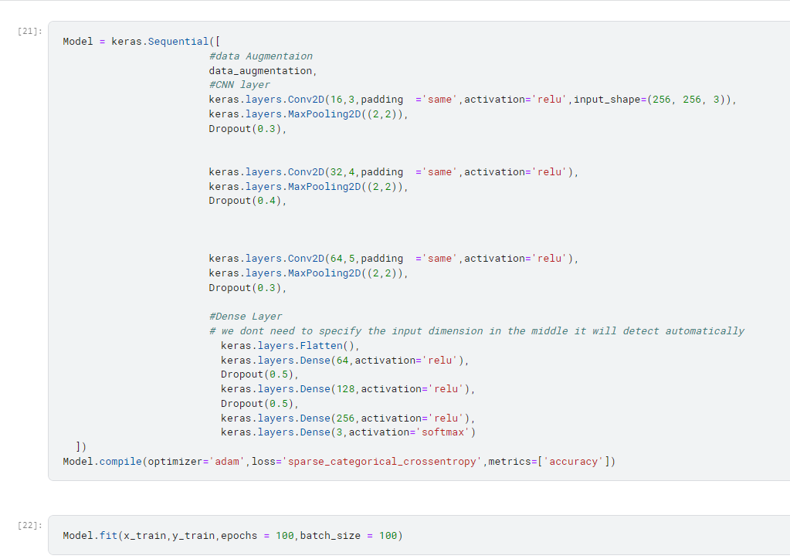

6.model accuracy

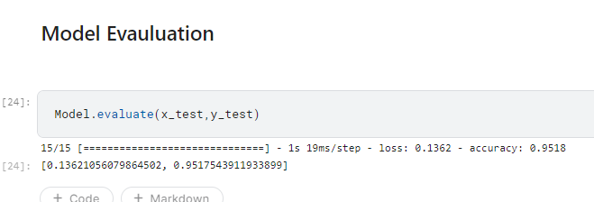

Streamlit UI :



1.After selecting a normal image :

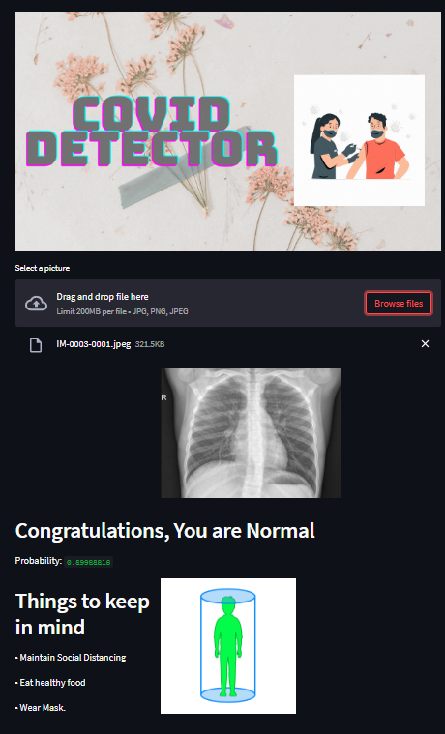

2. After selecting a covid positive image : 3. After selecting pnemonia

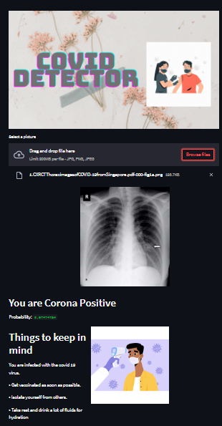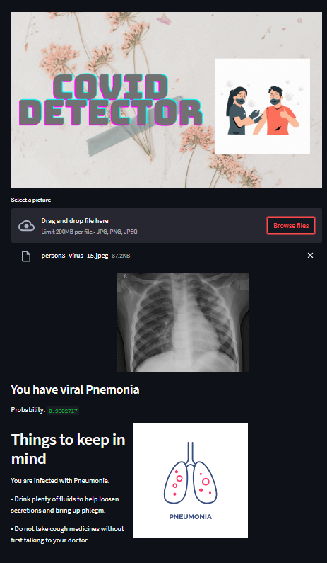

References

Abbas, A.; Abdelsamea, M.M.; Gaber, M.M.: Classification of COVID-19 in chest X-ray images using DeTraC deep convolutional neural network. Appl. Intell. **51**(2), 854–864 (2021)

https://towardsdatascience.com/convolutional-neural-networks-explained-9cc5188c4939#:~:text=A%20Convolutional%20Neural%20Network%2C%20also,binary%20representation%20of%20visual%20data